Performance Test

Date | 19 October 2026
Team ID | -
Project Name | Health360-Healthcare-Analytics
Maximum Marks

Project Performance Testing:
The purpose of performance testing is to verify that the Health360 healthcare dataset loads correctly, data preparation steps are reliable, calculated fields return accurate results, filters respond efficiently, and dashboards display visualizations correctly in Tableau Public.

Performance Testing Template
S.No. | Parameter | Screenshot / Values to Record
1 | Data Rendered | 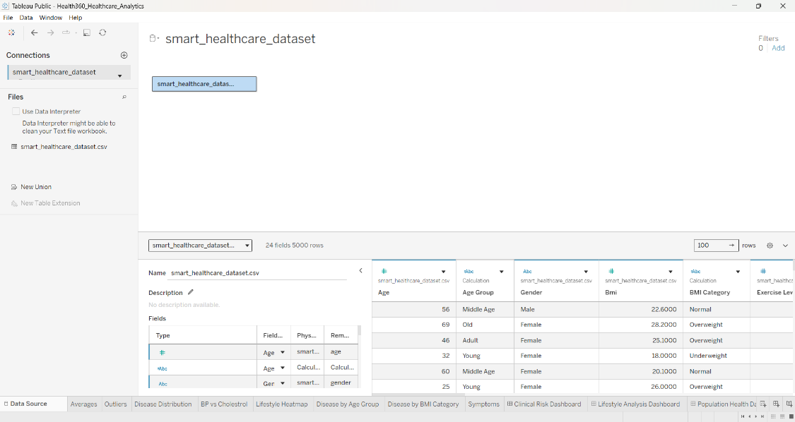
2 | Data Preprocessing & Quality | 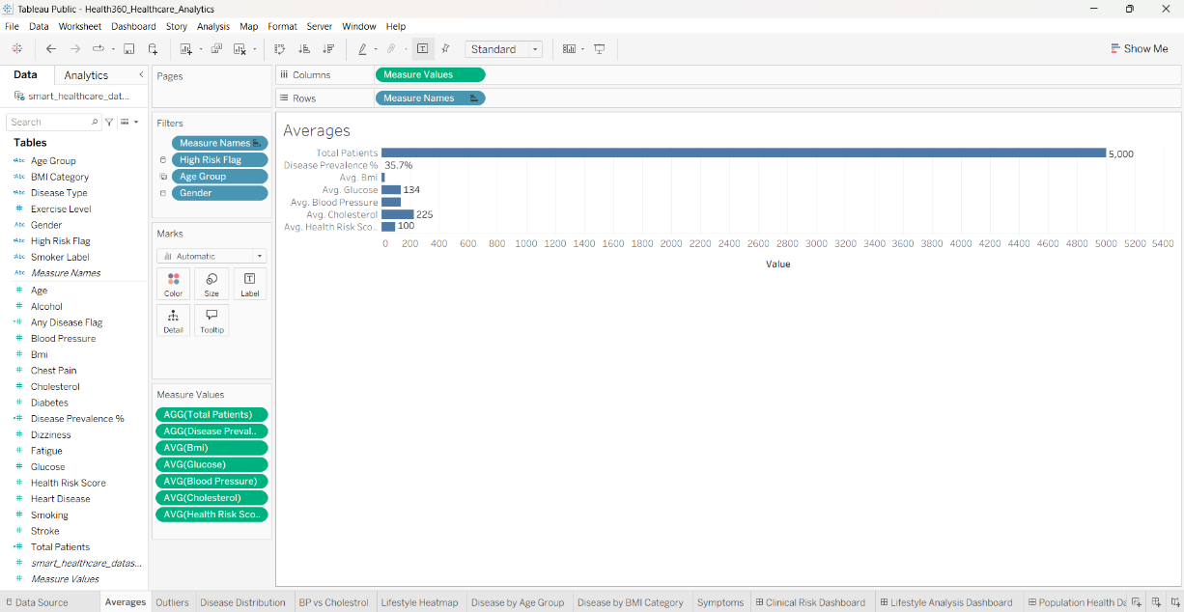
3 | New Fields Created | List calculated fields created in Tableau, such as Age Group, Disease Outcome Category, or Disease Outcome Percentage, where supported by the dataset. Include a screenshot of the calculated field and verify its results.
4 | Filter Efficiency Test | 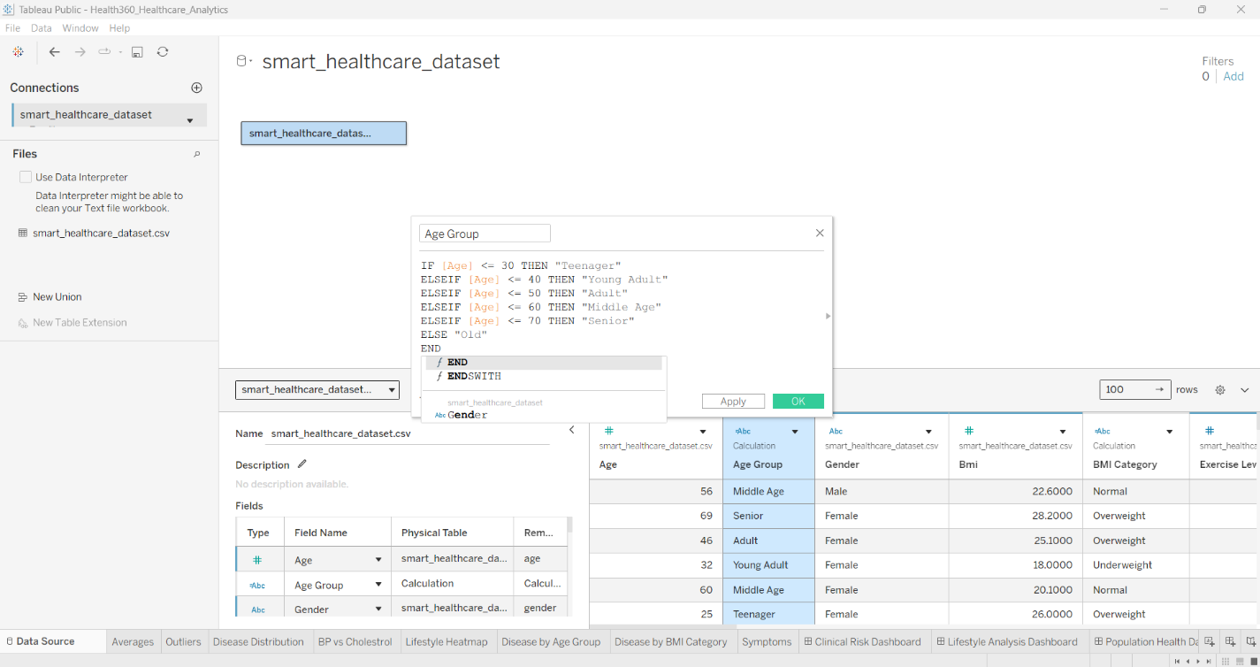
5 | Dashboard & Visualization Testing | 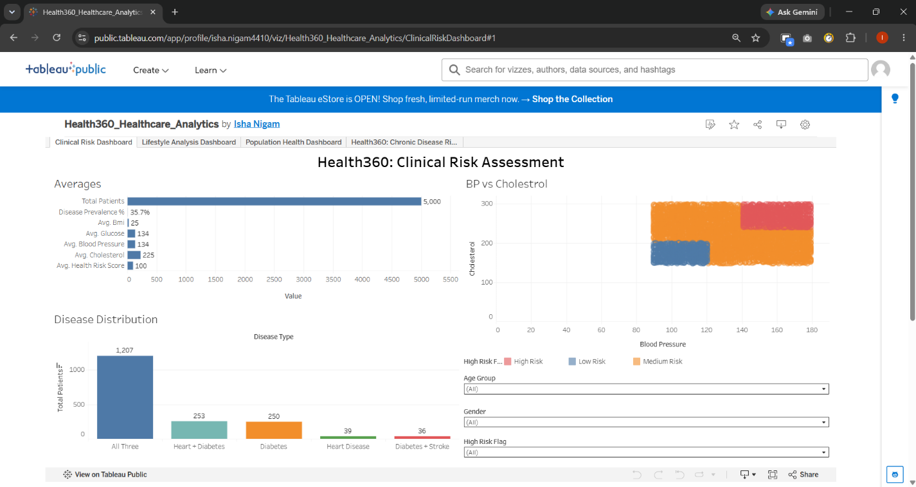
6 | Query / Performance History | Tableau Public does not provide SQL Query History for a local CSV connection. Record dashboard loading and filter response times if measured. If available, include Tableau performance recording evidence and identify the slowest operation.

Testing Procedure

1. Data Rendering Test
- Open the Data Source tab in Tableau Public.
- Confirm that the CSV file is connected and the fields are displayed correctly.
- Record the row count, column count, and CSV file size.
- Capture a screenshot as evidence.

2. Data Preprocessing and Quality Test
- Inspect fields for null or missing values.
- Check for duplicate records using a patient identifier, if available.
- Verify data types and inconsistent category labels.
- Confirm that cleaning and standardization steps do not change valid clinical values incorrectly.
- Record the issues identified and the actions taken.

3. Calculated Fields Test
- List all calculated fields created for the project.
- Check that age groups and disease outcome calculations use the correct fields.
- Verify percentages against the appropriate non-null denominator.
- Test calculations using a few records or compare them with manually verified totals.

4. Filter Efficiency Test
- Apply each filter separately and confirm the expected changes in charts and KPIs.
- Test multiple filters together.
- Clear or reset filters and verify that the dashboard returns to its default state.
- Record any incorrect results or noticeable delays. Do not report response times unless they have been measured.

5. Dashboard and Visualization Test
- Count the worksheets and visualizations actually included in the final dashboard.
- Check titles, axes, labels, legends, and tooltips.
- Confirm that all relevant charts respond correctly to filters.
- Capture screenshots of the final dashboard and important interactions.

6. Performance History Test
- Measure the time taken to load the dashboard and update visualizations after changing filters, if practical.
- For detailed performance analysis, use Tableau's Performance Recording feature if it is available in your Tableau Public workflow.
- Record the slowest observed operation and the conditions under which it occurred.

Expected Outcome
The project passes performance testing when the dataset loads correctly, data quality checks are documented, calculated fields produce valid results, dashboard filters work as expected, and visualizations display accurate information without significant usability issues.
All final measurements must be based on actual testing rather than estimated or assumed values.

